**‘AccessBank DBA Internship Program’**

**Project 25: Patching SQL Server**

1. **Check SQL Server instance’s version to see build number (16.0.1000.6 and RTM)**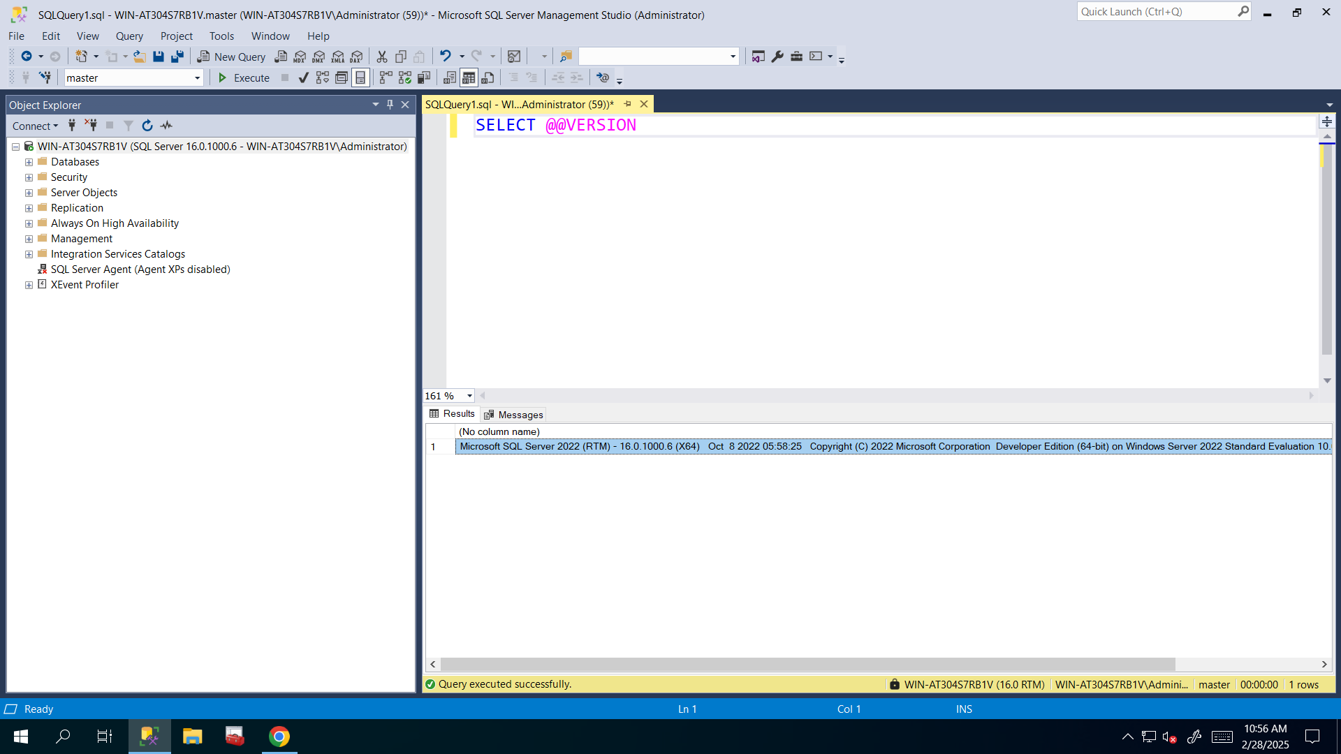
2. **Download the latest available Cumulative Update for SQL Server 2022 from Microsoft official site.**

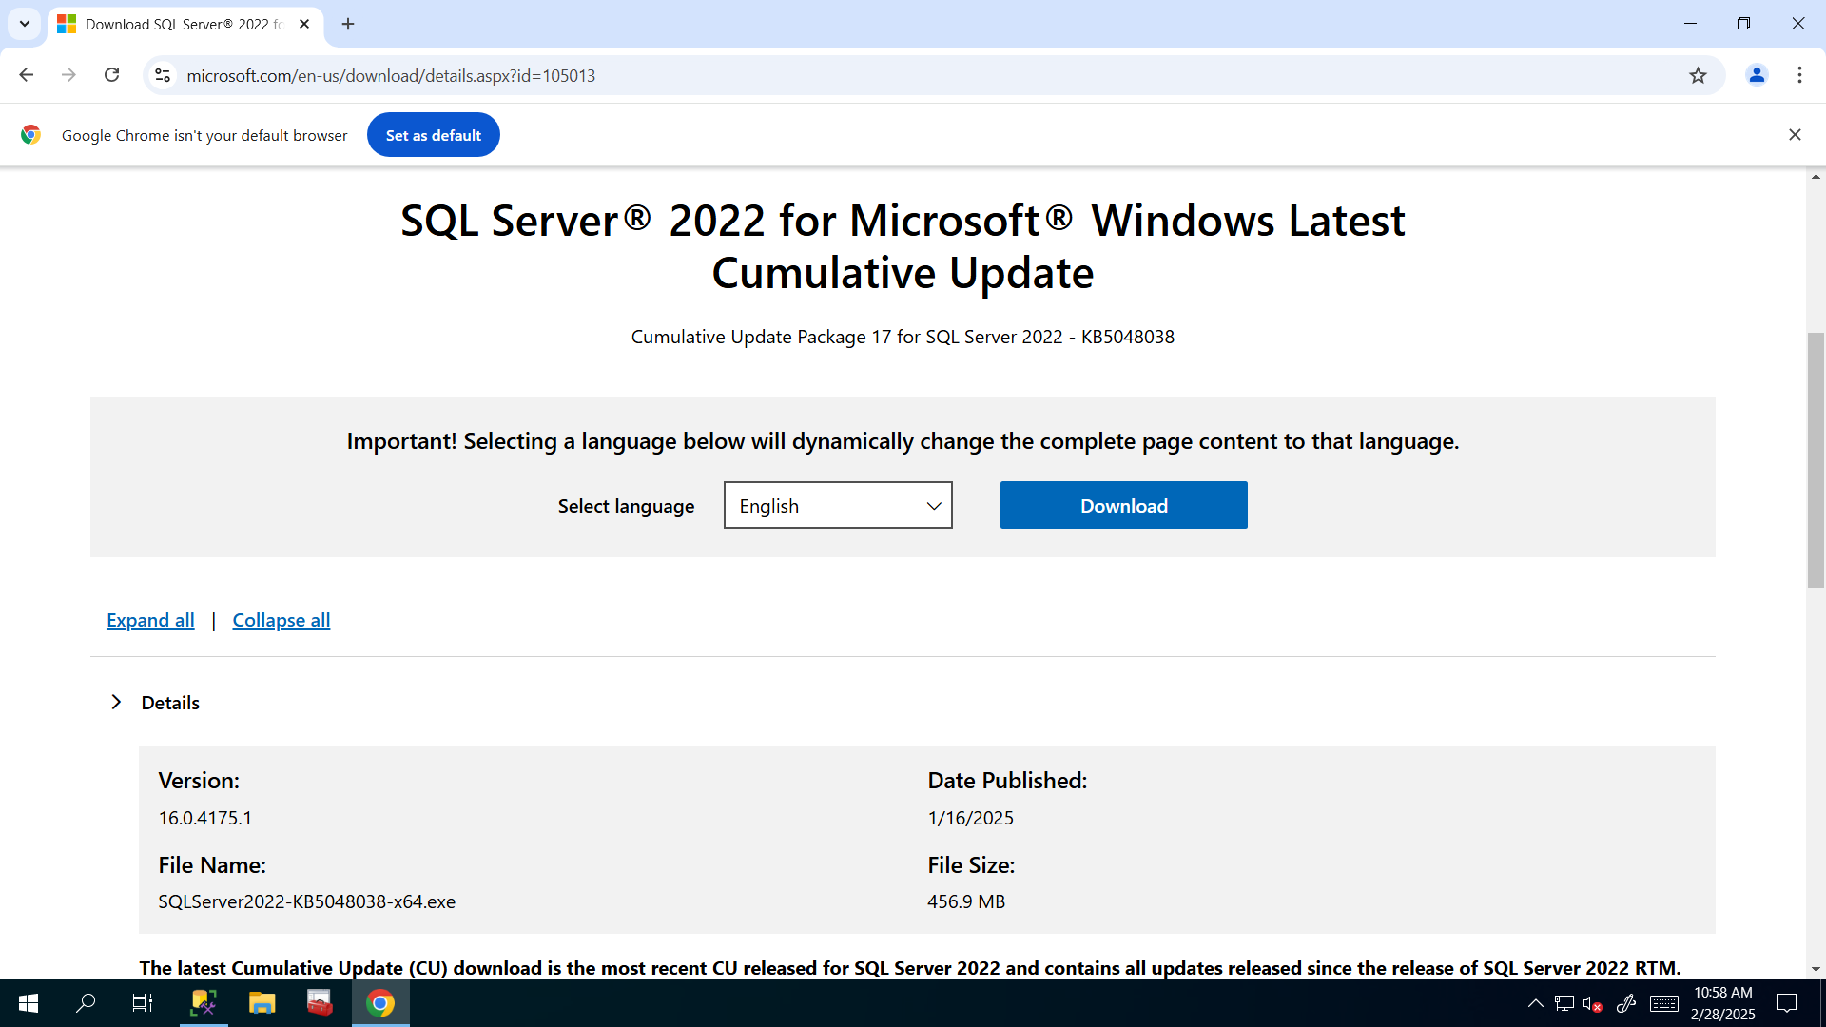

1. **Install the CU by clicking Run as Administrator**.

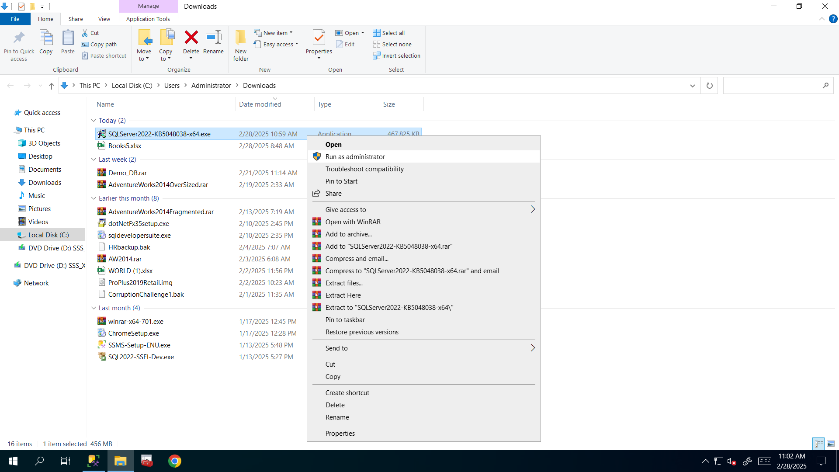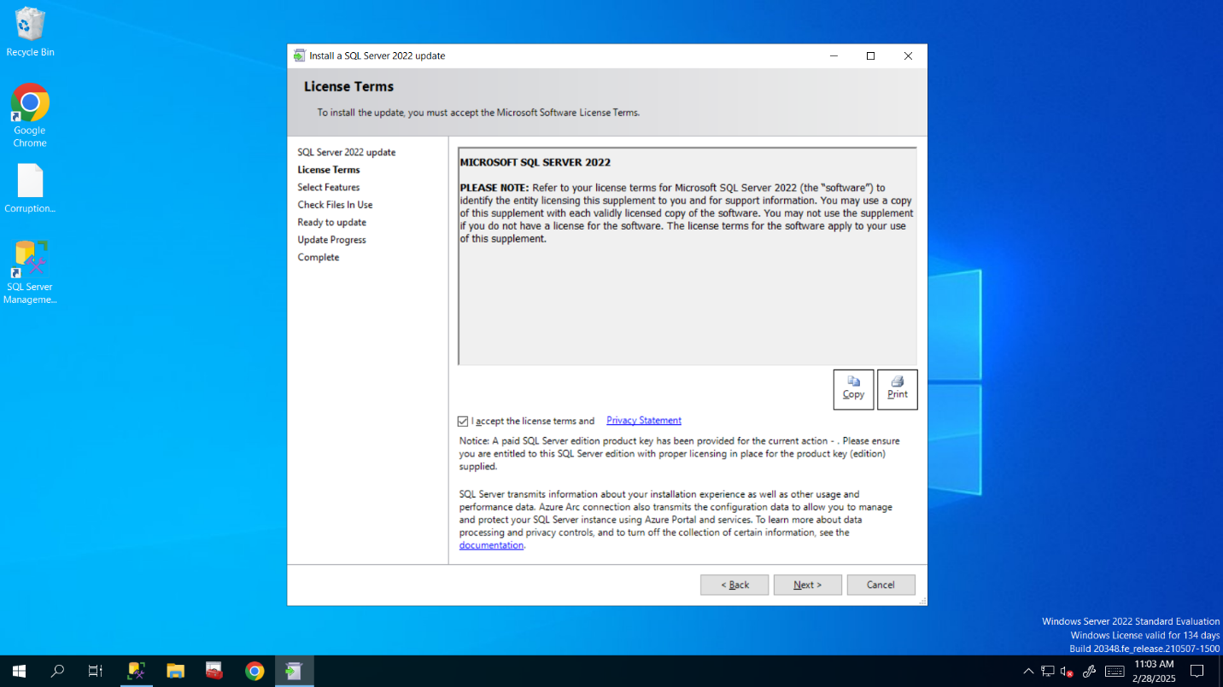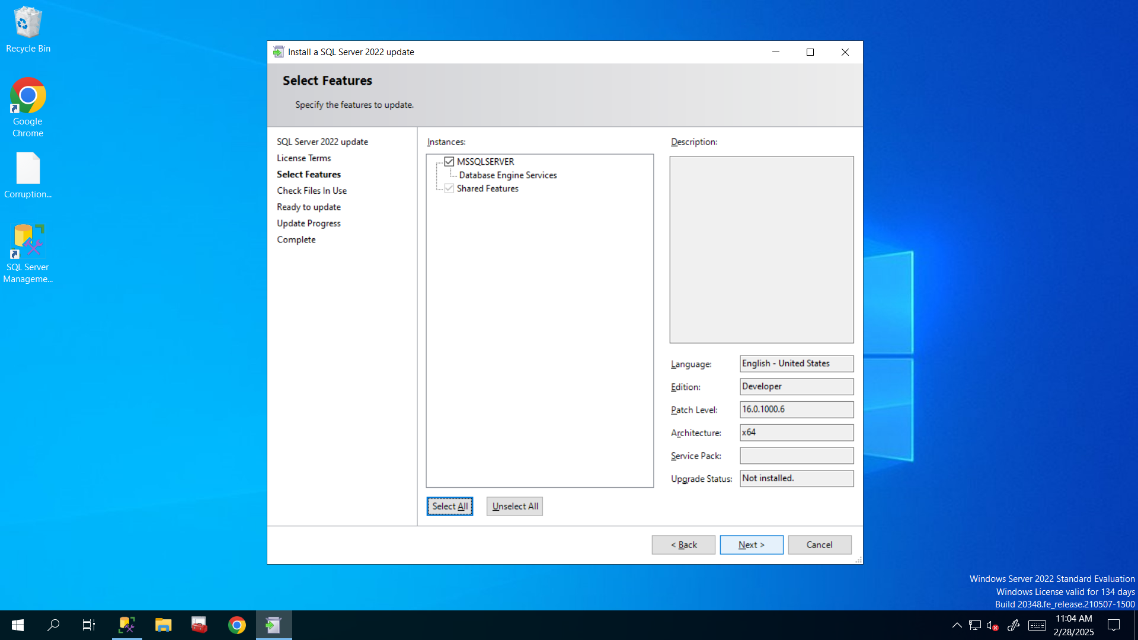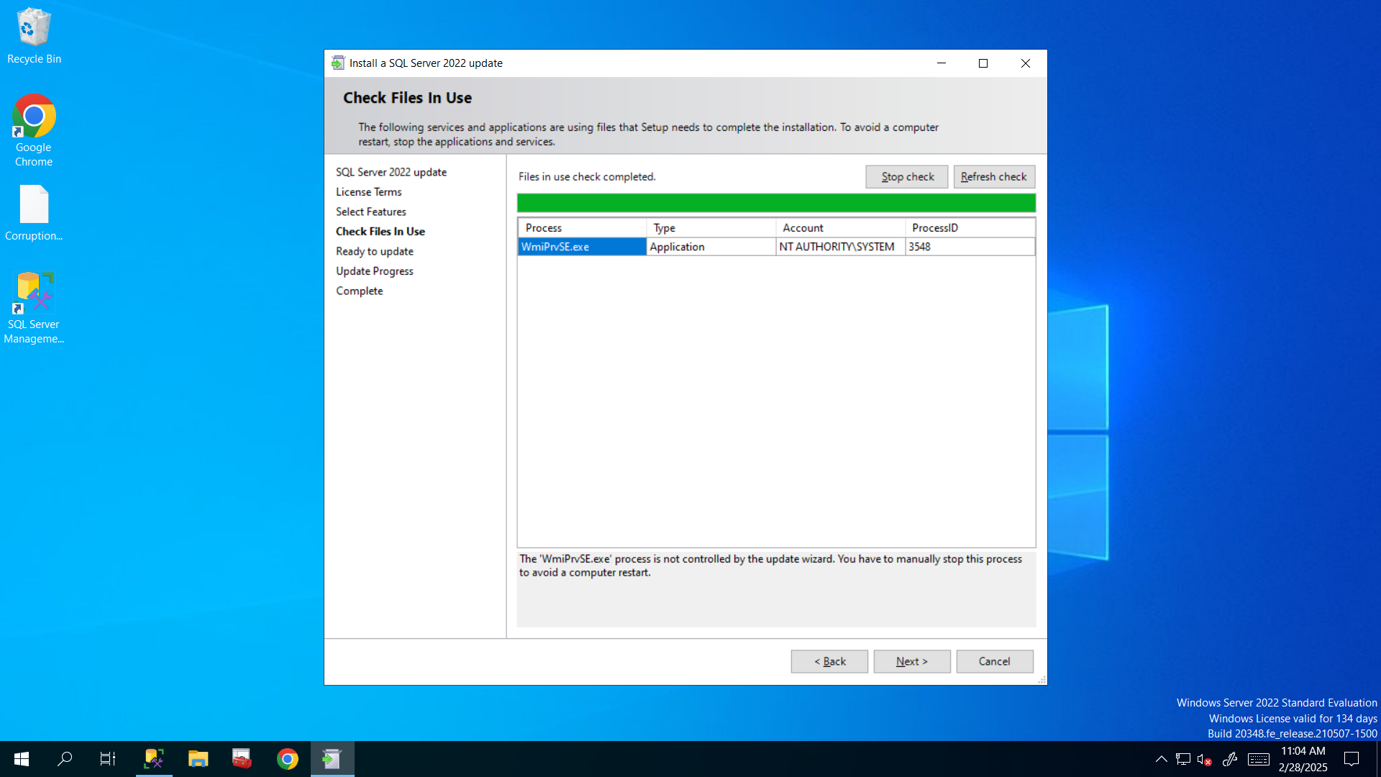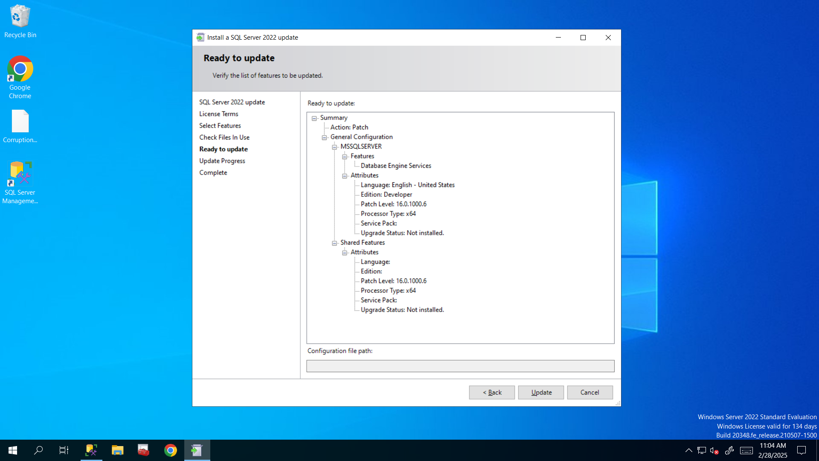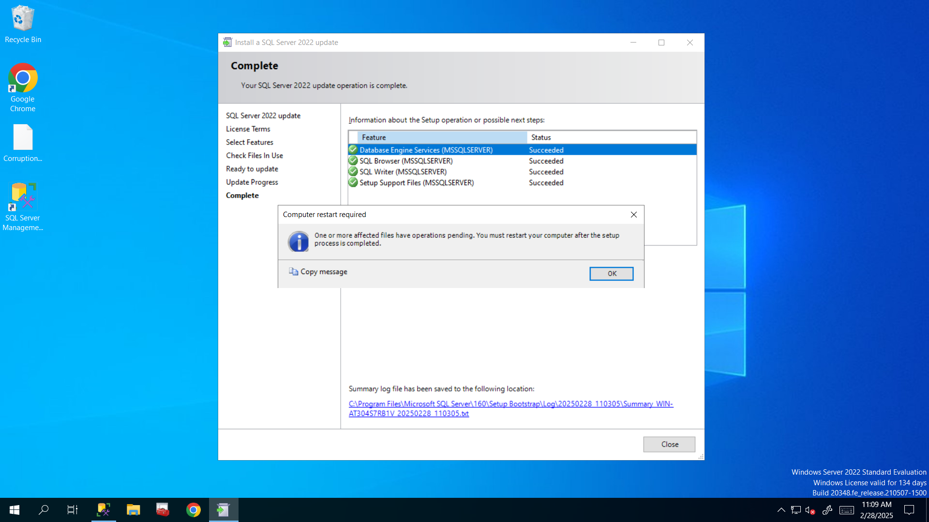

1. **Restart the VM**

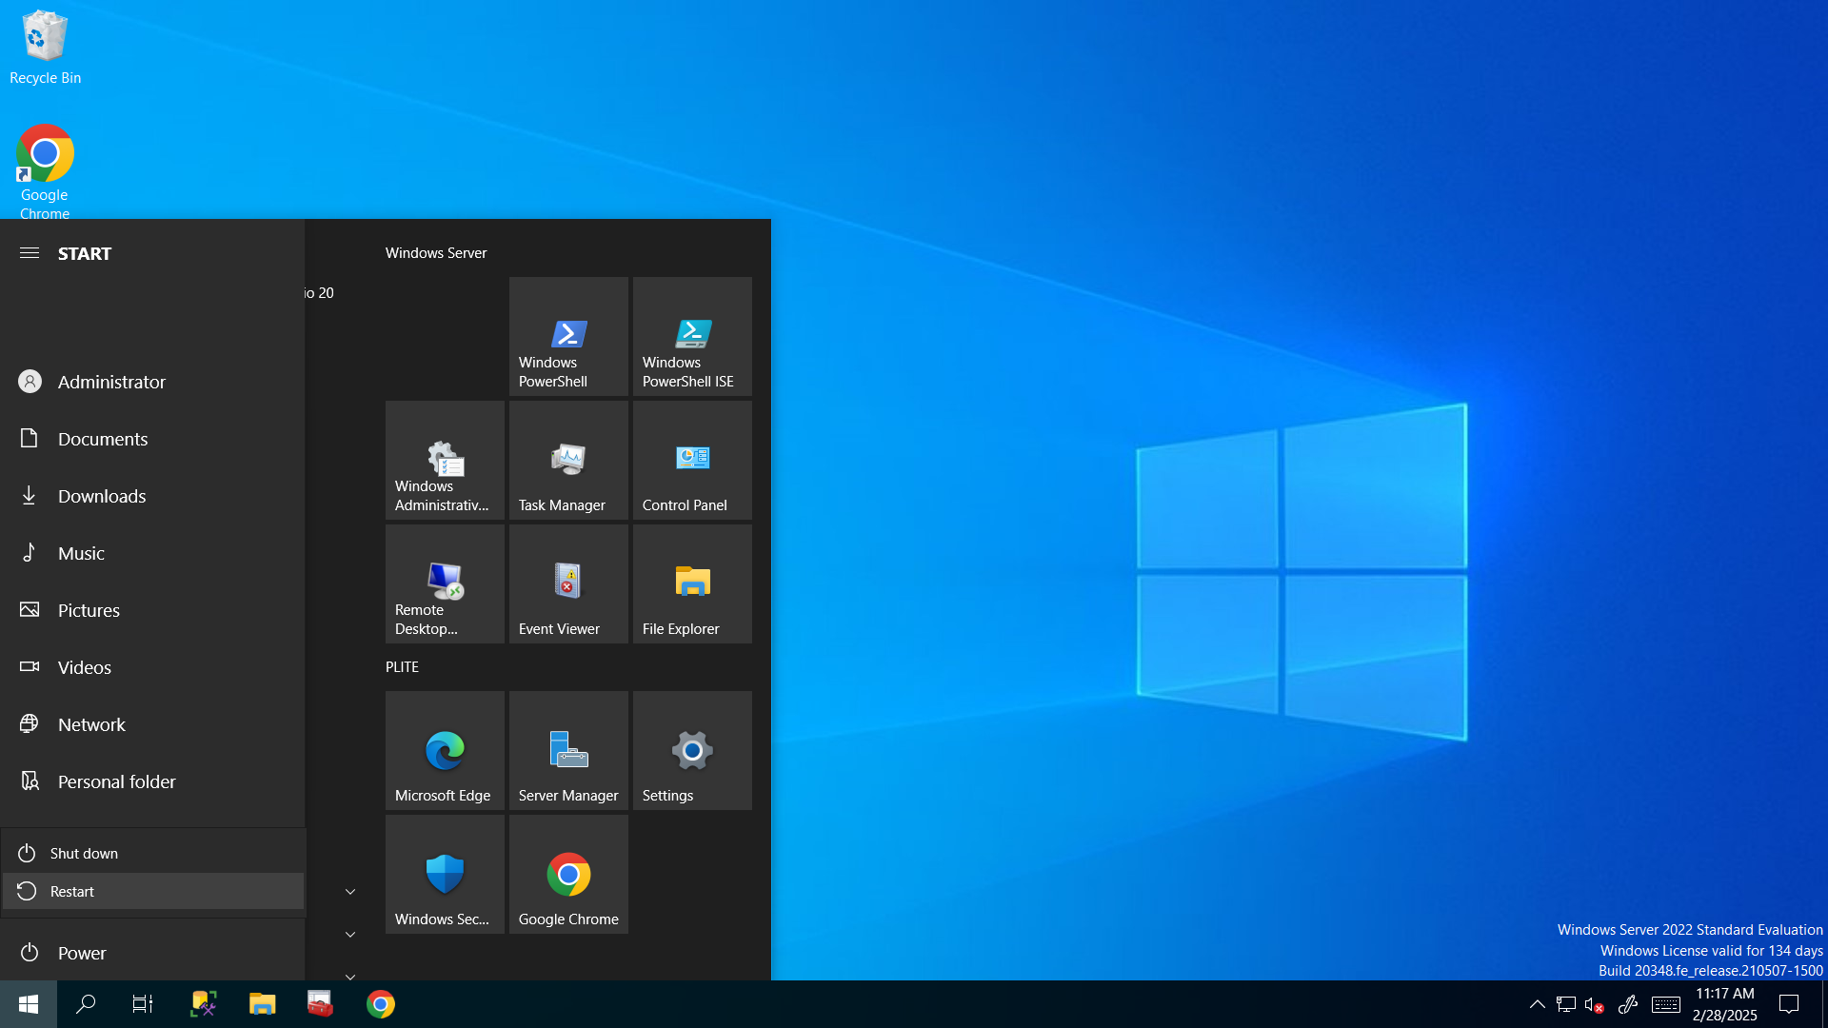

1. **Select @@version and now it is RTM-CU17 and build number is 16.0.4175.1**

